Project Design Phase-II Data Flow Diagram

|  |  |
| --- | --- |
| Date | 26 October 2022 |
| Team ID | **PNT2022TMID40966** |
| Project Name | **Fertilizers Recommendation System For Disease Prediction** |
| Maximum Marks | 4 Marks |

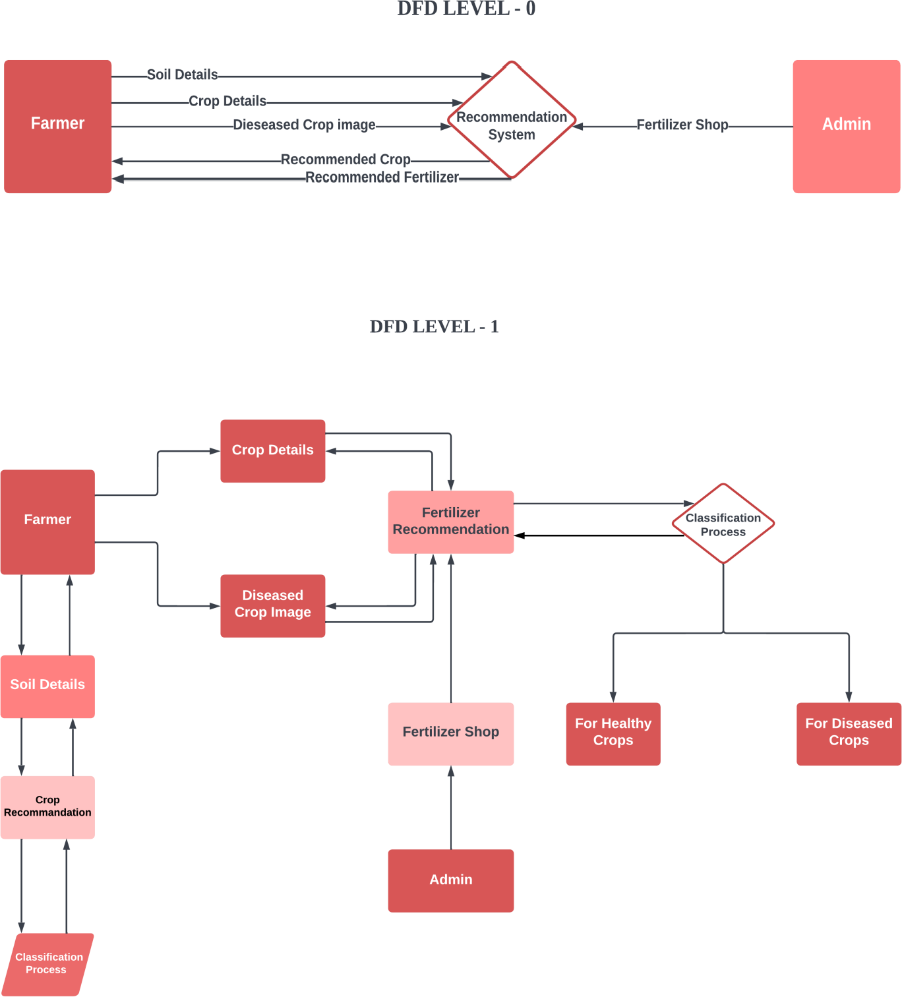

**User Stories**

Use the below template to list all the user stories for the product.

|  |  |  |  |  |  |  |  |  |
| --- | --- | --- | --- | --- | --- | --- | --- | --- |
| **User Type** |  | **Function al Requirement**  **(Epic)** |  | **User Story Number** | **User Story / Task** | **Acceptance criteria** | **Prior ity** | **Release** |
| **Customer (Mobile ssuser)** | Registration | | | USN-1 | As a user, I can register for the application by entering my email, password, and  confirming my  password. | I can access my account / dashboard | High | **Sprint- 1** |
|  | Login | | | USN-2 | As a user, I can log into the application by  entering email & password | I can login using my E- mail ID accounts or user  credentials | High | **Sprint- 1** |
|  | Dashboard | | | USN-3 | As a user, I can view the page of the application where i can upload and the fertilizer should be recommended | I can access my account/ dashboard | High | **Sprint- 2** |
| **Customer (Webuser)** | Registration | | | USN-4 | As a user, I can login to web dashboard just Like website dashboard | I can register using my  username and  password | High | **Sprint- 3** |
|  | Login | | | USN-5 | As a user, I can login to my web dashboard with the login  credentials | I can login using  my User credentials | High | **Sprint- 3** |
|  | Dashboard | | | USN-6 | As a user, I can view the web application where i can upload my images  and the fertilizer  should be recommended | I can access my account/ dashboard | High | **Sprint- 4** |
|  |  | | | USN-7 | As a user, the fertilizer recommended to me should be of higher  accuracy | I can access my account/ dashboard | High | **Sprint- 4** |
| **Administrator** | Login | | | USN-8 | As a admin, I can login to the website using my login credentials | I can login to the website using my login  credentials | High | **Sprint- 5** |
|  | **Dashboard** | | | **USN-9** | **As a admin, I can view the dashboard of the application** | **I can access my**  **dashboard** | **High** | **Sprint- 5** |